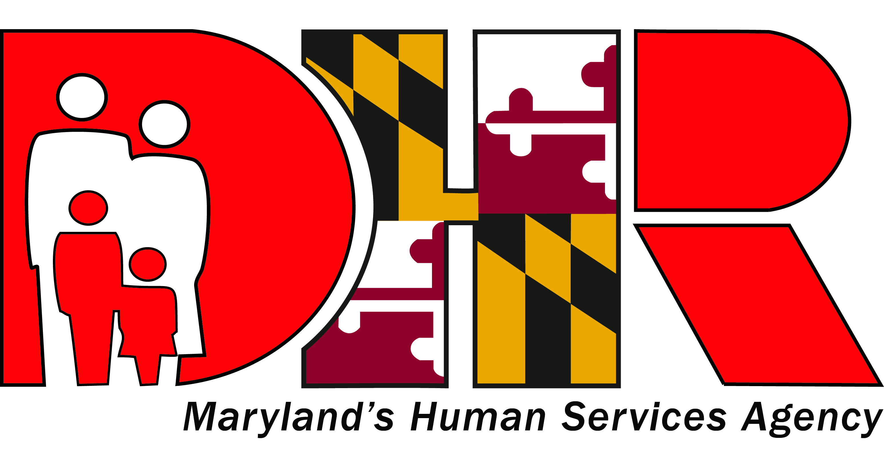

November 21, 2016

Contact: Kari Nye
(410) 767-8592
kari.nye@maryland.gov

Noncustodial Parents Step Onto Career Pathways in Baltimore
New partnerships facilitate job-training, job placement, and family-sustaining wages for Baltimore City noncustodial parents

Baltimore—Where can a noncustodial parent who was recently released from four years in prison, who has nine children and six active noncompliant cases, find a program that results in his securing two jobs, right-sizing his four child support orders, fully meeting his support obligations, obtaining custody of one of his children, and closing five of his open cases? If the parent lives in Baltimore City, he can turn to STEP Up.

During the 2016 Legislative Session, the DHR Child Support Enforcement Administration (CSEA) achieved passage of House Bill 1502, which created the three-year, city-wide pilot program now called STEP (Supporting, Training, and Employing Parents) Up. This new law targets Baltimore’s low-income, unemployed, and underemployed noncustodial parents, helping them obtain job training and employment, become economically self-sufficient, and make consistent child support payments.

STEP Up was developed by CSEA in close partnership with DHR’s Family Investment Administration and the Baltimore City Office of Child Support Services. The program is also working closely with the Mayor’s Office of Employment Development, Baltimore City Circuit Court, and Baltimore City Department of Social Services. STEP Up is open to all noncustodial parents who have a Baltimore City child support case and are subject to the jurisdiction of the Baltimore City Circuit Court.

Over the course of the first year of the pilot, CSEA anticipates on enrolling about 360 noncustodial parents. Baltimore City has Maryland’s largest child support caseload, representing approximately one-third of all child support cases in the state. The city is also home to a powerful network of community-based organizations that administer successful job-driven training programs and are supported by the strong leadership and experience of the Baltimore City Office of Child Support Services.

Those who are interested in getting connected with the program should contact Fatima Lewis or any program STEP Up staff by calling at (410) 951-8000. They can also visit the office in Baltimore City at 1 North Charles Street on the fifth floor. In addition, any organizations or groups who would like to coordinate a visit from the STEP Up! outreach team should contact Theresa Lee at tt.lee@maryland.gov.

###

